The Truck Problem
METC 111
5/8/2018
Charity Fischer

The Truck Problem
The goal of this project was to resolve the forces four cables attached to a platform that holds a M939 Series marine vehicle. The truck weighs 21,470 pounds that is 307.4 inches in length, 97.5 inches wide, and 115 inches tall. The platform is to be the length of the vehicle plus 20% of the height multiplied by the width of the vehicle plus 20% of the height. This brings the dimensions of the platform to 330.4 inches by 120.5 inches. The cables attached to the four corners of the platform are to converge at 200% of the vehicles height which come out to be 230 inches above the center of the platform. When the dimensions are put together they make a platform like the one below.
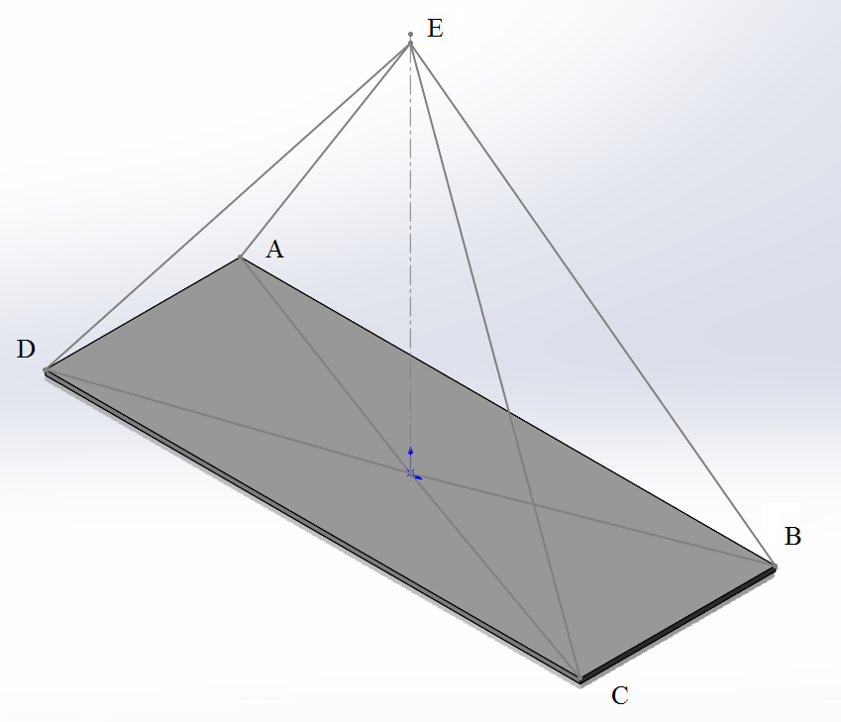
The weight of the truck is centered at the same point where I’ve placed the origin; in the center of the platform, which means that all the cables have an equal force acting on them. I’ve labeled the points by first starting at the negative x and positive y quadrant of the x-y plane and went clockwise about the platform before moving in the positive z direction to label the point where the four cables converge above the center of the platform.
To find the force in each cable we must first find the position vector, or Cartesian vector, of each cable. To do this I first made ordered triples for each point:
A = (-165.2,60.25,0)
B = (165.2,-60.25,0)
C = (165.2,-60.25,0)
D = (-165.2,60.25,0)
E = (0,0,230)
When this is completed they must be put through the equation F = {(Xb-Xa)i+(Yb-Ya)j+(Zb-Za)k}. When this is done for each AE, BE, CE, and DE the position vectors we are given are as follows:
F_{AE} = -165.2i+60.25j-230
F_{BE} = 165.2i+60.25j-230
F_{CE} = 165.2i-60.25j-230
F_{DE} = -165.2i-60.25j-230
By using only one of these position vectors the magnitude of all cables can be calculated with $A=\sqrt{Ax^{2}+Ay^{2}+Az^{2}}$. Using F_{AE} in this equation looks like this;
$A= \sqrt{{\left(-165.2\right)}^{2}+{\left(60.25\right)}^{2}+{\left(-230\right)}^{2}}$
= 289.52
We now know the magnitude which is equal to the length of the cable. This can be verified with the following equations.
A to origin = $\sqrt{{\left(165.2\right)}^{2}+{\left(60.25\right)}^{2}}$ = 175.84
A to E = $\sqrt{{\left(175.84\right)}^{2}+{\left(230\right)}^{2}}$ = 289.52
Next is to find the unit vector of each cable by dividing the position vector by the magnitude.
U_{AE} = $-\frac{165.2}{289.5}i+\frac{60.25}{289.5}j-\frac{230}{289.5}k$
U_{BE} = $\frac{165.2}{289.5}i+\frac{60.25}{289.5}j-\frac{230}{289.5}k$
U_{CE} = $\frac{165.2}{289.5}i-\frac{60.25}{289.5}j-\frac{230}{289.5}k$
U_{DE} = $-\frac{165.2}{289.5}i-\frac{60.25}{289.5}j-\frac{230}{289.5}k$
I found the angle between the line of point E to the origin and line AE by first finding angle between the line A to the origin and line AE which is done by taking the inverse tangent of the distance and subtracting that from 90° which we know to do because it is a square triangle.
$90°-\tan^{-1}{(\frac{230}{175.84})}$ = 37.4°
Then this can be put into the equation Tcosa = F where F is the weight of the truck, and is the angle just solved. When solved the Tension in the cable is 27,026 lb. When this number is divided by the number cables, which is 4, this gives us the force in pounds in each cable which is 6756.5 lbs.

